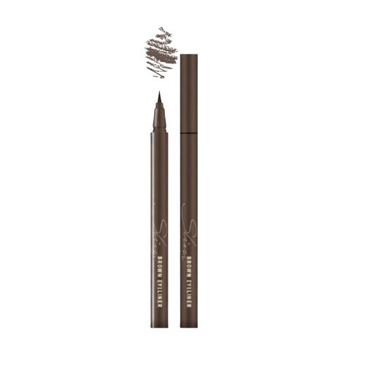
Name : Slim brown eyeliner
Description : Slim Brown Eyeliner gives a natural and soft eye look. It is easy to apply and helps define the eyes smoothly. The brown color is perfect for everyday makeup.

How to use :
- Start with clean, dry eyelids.
- Gently draw a thin line along the upper lash line.
- Begin from the inner corner and move outward.
- For a darker look, apply another layer.
- You can also lightly apply on the lower lash line for a soft finish.

